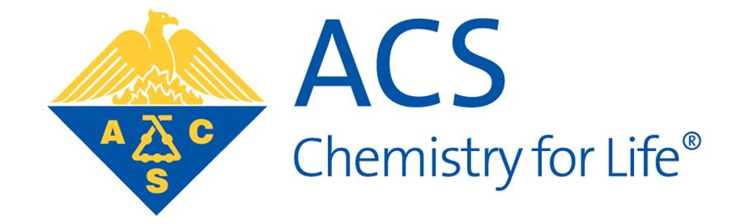

ACS Brazosport Section Awards
Call for Student Scholarship Nominations

The Brazosport Section is calling for nominations for two $1,000 scholarships to graduating high school seniors from Brazoria County.

The scholarships are awarded to students who have demonstrated outstanding academic achievement in the field of chemistry and plan to continue their studies (in either chemistry or chemical engineering) at the college or university level. Consideration will also be given to the financial need of the applicant.

To submit a nomination, please complete the Scholarship Application form and submit it directly to (pboopalachandran@dow.com) or the Brazosport ACS website (High School Student Scholarship | ACS Brazosport) before April 1st, 2026.

To request for further information, please contact:

Praveen Boopalachandran, Ph.D.
Awards Committee Chair
American Chemical Society, Brazosport Section
ECB, Off: 1B153 | Lab: Module 62
230 Abner Jackson Pkwy
Lake Jackson, TX 77566
Tel: 979-238-1371
Email: pboopalachandran@dow.com

